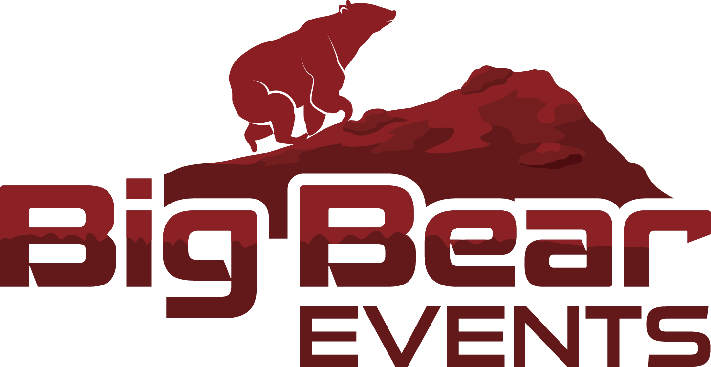

Big Bear Events
March 2023
July 2020

Big Bear Events
Equality, Diversity and Inclusion Policy

Big Bear Events
Equality, Diversity and Inclusion Policy

Policy Owner: Paul Albon
Policy approved by: Paul Albon
Date Policy approved: 15/03/2023
Next review Date: 15/03/2025

Introduction

For the purposes of this policy ‘inclusion’ means access for all. It means recognising differences between individuals / groups and providing opportunities for them to participate in running and exercise regardless of those differences, whether this is as a participant, coach, leader, official, volunteer or member of staff.

Big Bear Events Ltd embraces diversity and difference and is committed to providing opportunities that are safe, inclusive, accessible and equitable. We want our organisation to be equally accessible to all members of society, whatever their age, disability, gender, race, ethnicity, sexuality or social/economic status.

We will develop a focus on inclusion, not exclusion, and ensure that we provide appropriate advice to staff, members, volunteers and 3rd parties to ensure that everyone can participate as fully as possible. The Inclusion Policy is intended to promote a change in attitudes and perceptions and to improve opportunities for everyone to participate at our organisation.

We will seek to ensure that we comply with the Equality Act 2010 and the characteristics protected by it (age, disability, gender reassignment, race, religion or belief, sex, sexual orientation, marriage and civil partnership and pregnancy and maternity) and encourage our stakeholders to do so. We will seek to include everyone regardless of whether they have a protected characteristic or not.

Our aim is to provide an environment where everyone feels:
- Welcome
- Represented
- Included in decision making
- Able to participate
- Safe and free from discrimination, bullying, harassment and vilification.
Aims
The aims of the Inclusion Policy are:
- To promote the development of knowledge and understanding of disability, equity and inclusion amongst our staff, members, volunteers and 3rd parties by the provision of appropriate guidance and training. To guide and support the integration of inclusive practice into all of Big Bear Events Ltd’s programmes and activities.
- To contribute towards growing and sustaining numbers of people from under-represented groups participating within our organisation.
- To promote inclusion within our events wherever possible and in accordance with the provisions of the Equality Act.
- To adopt inclusive practice within our competition and events.
- To promote close working partnerships with relevant groups and organisations to support the development of inclusive practice within our club.

Commitment
We will;
- Not tolerate discrimination, harassment, bullying or victimisation.
- Actively identify and reduce barriers to participation for under-represented groups.
- Consult with expert partners and other organisations to facilitate inclusive practices and remove barriers to participation.
- Ensure under-represented groups are given the opportunity to participate in all aspects of our organisation.
- Provide opportunities for all in coaching, officiating and leadership positions.
There are a number of measures that we will take to ensure that we are working under the guidance of the Policy and within the requirements of the Equality Act (2010).
We will provide a welcoming environment
- We will think positively about how we can include people rather than focusing on potential barriers to participation.
- We will consider how our organisation is promoted. For example, by providing information in formats which are accessible and by using appropriate imagery.
- We will encourage people to contact us to discuss their needs and requirements to facilitate inclusion and we will ensure we consider what reasonable adjustments could be made to enable them to participate.
- We will develop the knowledge and understanding of key officials, coaches, leaders and other volunteers, of disability, equity and inclusive practice by providing appropriate guidance and training.
We will talk to people
- We will, so far as is reasonably possible, consult with relevant groups and with prospective individuals about their needs and requirements.
- We will not make assumptions and will try to speak to people about the reasonable adjustments they believe might be made to enable them to participate and to discuss how these could be made.
We will make reasonable adjustments
- We will demonstrate that every effort has been made to enable everyone to participate and that inclusion not exclusion has been the priority.
- If reasonable adjustments are required to make an event/activity accessible, then we will make those reasonable adjustments.

